

COLLEGE of INFORMATICS and ELECTRONICS

Department of Computer Science
and Information Systems

End-of-Semester Assessment Paper

Academic Year: | 2004/2005 | Semester: | Autumn
Module Title: | Software Architecture | Module Code: | CS4135
Duration of Exam: | 2 Hours | Percent of Total Marks: | 30
Lecturer(s): | Prof. Anthony Cahill, J.J. Collins, and Eugene Glynn | Paper marked out of : | 30

Instructions to Candidates:
- Answer any three questions.
- It is at your discretion whether or not a diagram would be of value in illustrating your discussion, when one has not been explicitly requested in the question to reproduce one.
- Poor handwriting and illegibility will result in a loss of marks.

Q1 | Answer ALL parts. Total marks awarded for this question: 10.
 | a) | Describe the difference between static and dynamic binding of methods
 |  | 3 marks.
 | b) | List the main differences between an abstract class and an Interface in Java.
 |  | 3 marks.
 | c) | Briefly explain the rationale underlying these differences.
 |  | 4 marks.

Q2 | Answer ALL parts. Total marks awarded for this question: 10.
 | a) | What is a layout manager?
 |  | 3 marks.
 | b) | Describe two layout managers of your choice.
 |  | 3 marks.
 | c) | Given the code fragment in listing 1 at the end of this document,  recover a diagram that accurately models the program.
 |  | 4 marks.

Q3 | Answer ALL parts. Total marks awarded for this question: 10.
 | a) | Given the class diagram fragment in figure 1, use collection class(es) to design  the one-way one-to-many association owns between Campaign and Advert.  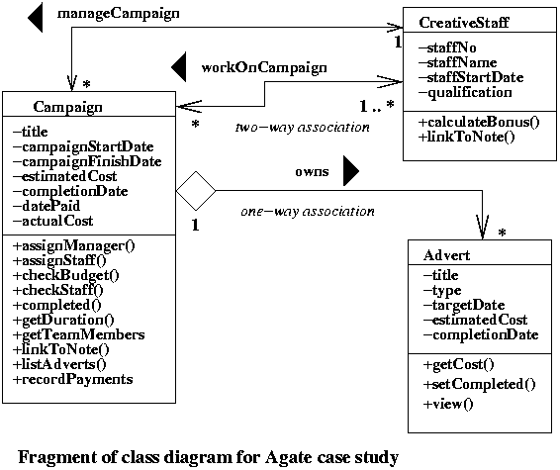  Figure 1.
 |  | 3 marks.
 | b) | Two complimentary notations – A and B, are shown in figure 2 to model interfaces.  - What is the purpose of an interface in software engineering?  - What is the difference between an interface and abstract class?  - Identify the error in figure 2.
 |  | 3 marks.
 | c) | Write a basic Java class to create a JPanel and a JButton. The Jbutton should display the text “Click Me”. Add the JButton to the JPanel. Add a MouseListener to the JButton to display the string “Clicked” on the command line when the user clicks on the JButton. Note: The following methods are required to be implemented in your class by the MouseListener interface: mouseClicked, mouseEntered, mouseExited, mousePressed, mouseReleased. For the methods that you do not need, you may provide an empty implementation.
 |  | 4 marks.
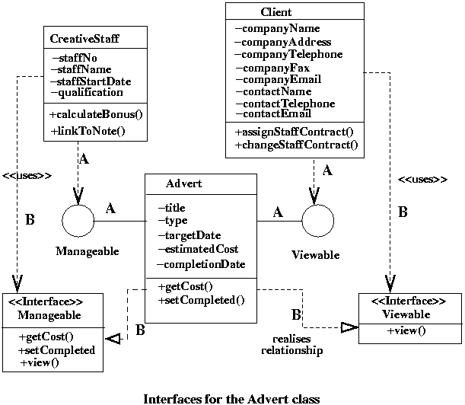

Figure 2

Q4 | Answer ALL parts. Total marks awarded for this question: 10.
 | a) | What is the difference between a pattern and a framework.
 |  | 3 marks.
 | b) | Describe Gamma et al.’s state pattern with emphasis on  context and forces. Illustrate your answer with a diagram.
 |  | 3 marks.
 | c) | Describe Gamma et al.’s composite pattern with emphasis on  context and forces. Illustrate your answer with a diagram.
 |  | 4 marks.

Q5 | Answer ALL parts. Total marks awarded for this question: 10.
 | a) | According to Shaw et al (1995), what are the requirements of an architecture  description language (ADL) ?
 |  | 3 marks.
 | b) | Illustrate with a sequence diagram the dynamics of the broker  architectural pattern without bridge components.
 |  | 3 marks.
 | c) | Describe Smalltalk’s Model View Control (MVC) architecture, and illustrate  with the use of a diagram. Draw a sequence diagram to model the initialisation  protocol for an architecture that adheres to the MVC.
 |  | 4 marks.

Listing 1.

import java.awt.*;
import java.awt.event.*;
import javax.swing.*;
class TicTacToe extends JFrame{
JPanel board = new JPanel();
JPanel players = new JPanel();
JButton squares[] = new JButton[9];
JButton newGame;
String nextPlayer;
public TicTacToe(){
// create board
for(int j = 0; j < 9; j = j + 1){
squares[j] = new JButton();
squares[j].setEnabled(false);
}
board = new JPanel();
board.setLayout(new GridLayout(3,3));
for(int j = 0; j < 9; j = j + 1){
board.add(squares[j]);
squares[j].addActionListener(new SquareListener(j));
}
newGame = new JButton("New Game");
newGame.addActionListener(new NewGameListener());
players.add(newGame);

Container c = getContentPane();
c.setLayout(new BorderLayout());
c.add(board, BorderLayout.CENTER);
c.add(players, BorderLayout.SOUTH);
addWindowListener(new WindowAdapter(){
public void windowClosing(WindowEvent e){
dispose();
}
});
}
class SquareListener implements ActionListener{
int index;
public SquareListener(int k){
index = k;
}
public void actionPerformed(ActionEvent e){
squares[index].setText(nextPlayer);
squares[index].setEnabled(false);
if(nextPlayer.equals("X"))
nextPlayer = "O";
else
nextPlayer = "X";
}
}
class NewGameListener implements ActionListener{
public void actionPerformed(ActionEvent e){
for(int j = 0; j < 9; j = j + 1){
squares[j].setText("");
squares[j].setEnabled(true);
}
nextPlayer = "X";
}
}
}

